**Screenshorts of School management Practice Project**

1. **School Management**

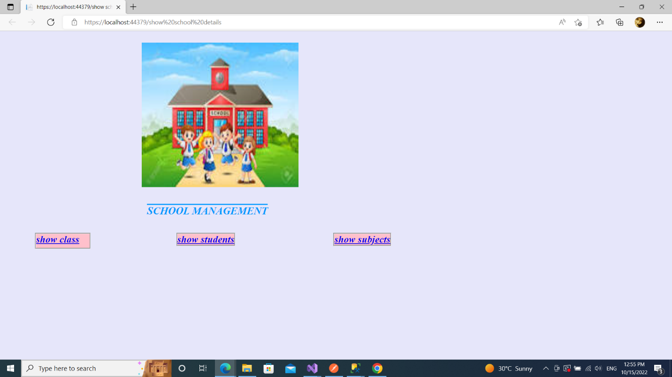

1. **Class Details**

1. **Student Details**

1. **Subject Details**

